**Java Payroll System**

Group 16

**PAYROLL**

**CODES**

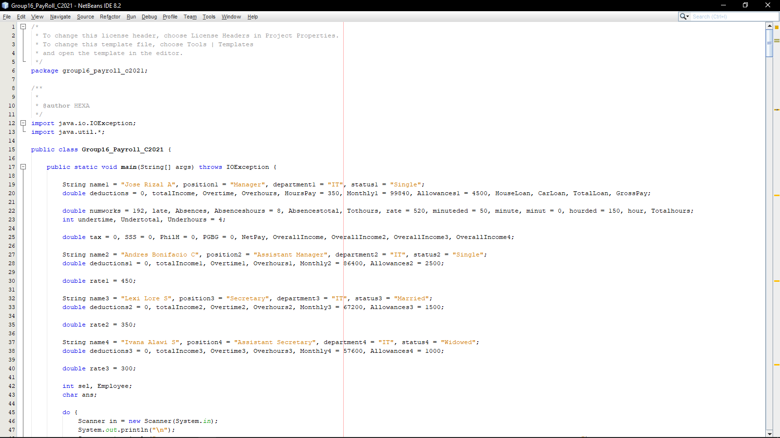 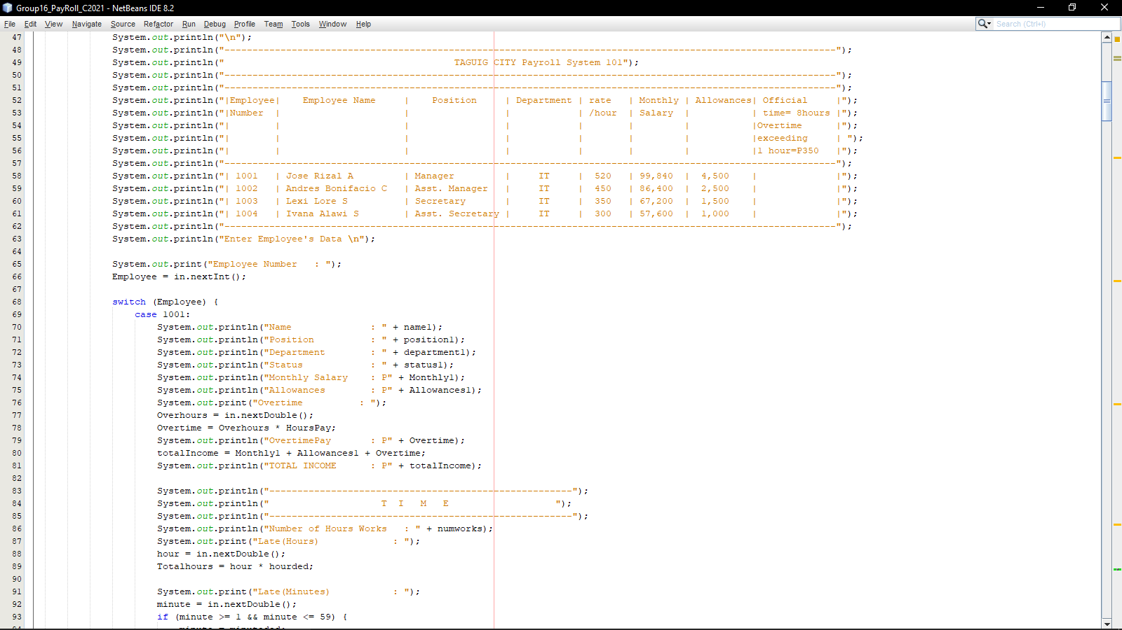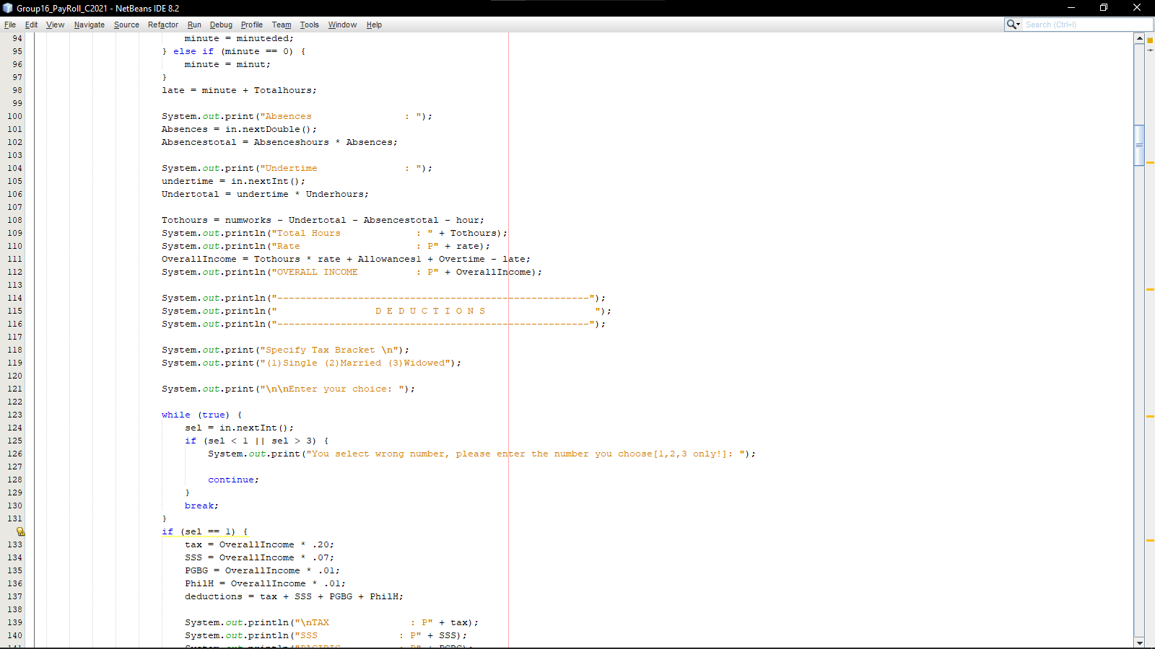 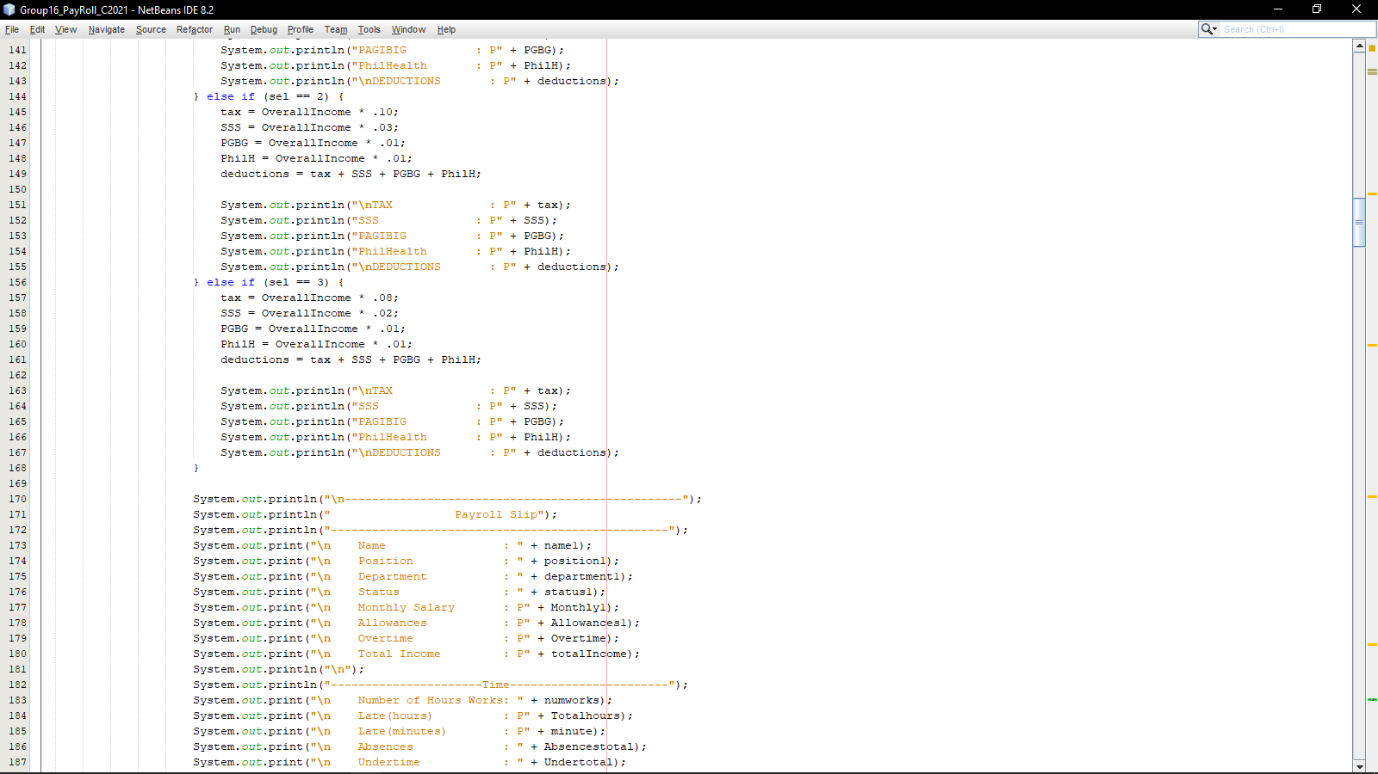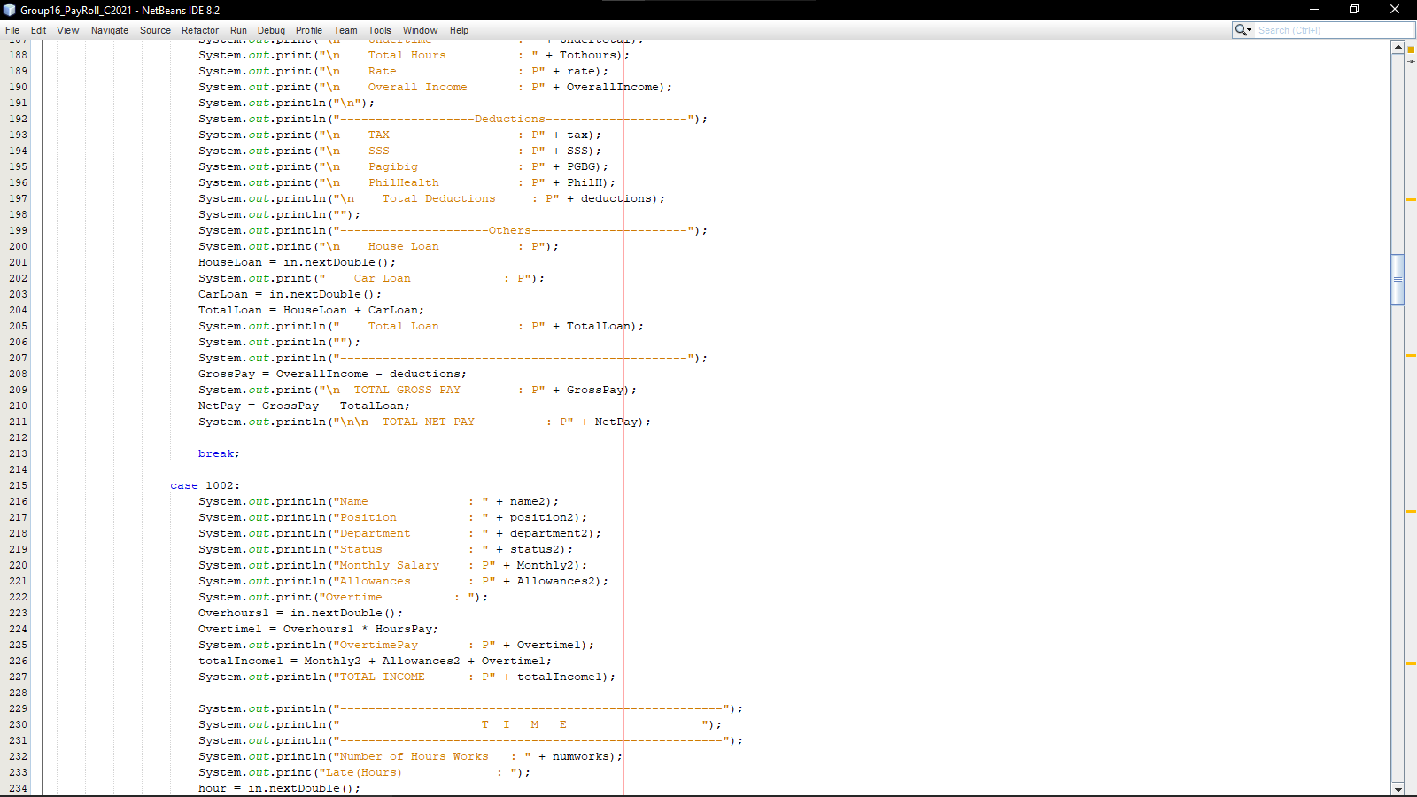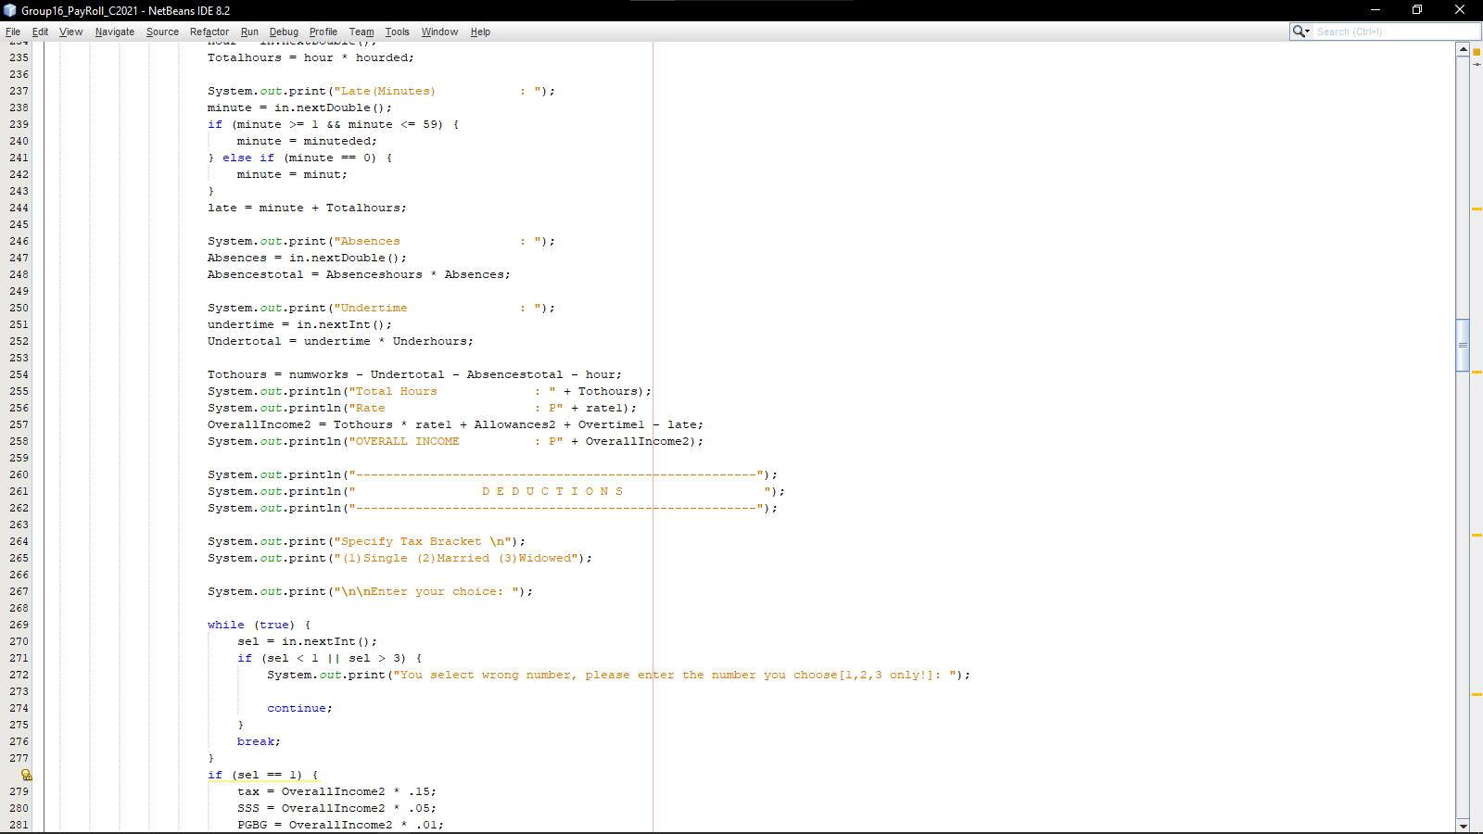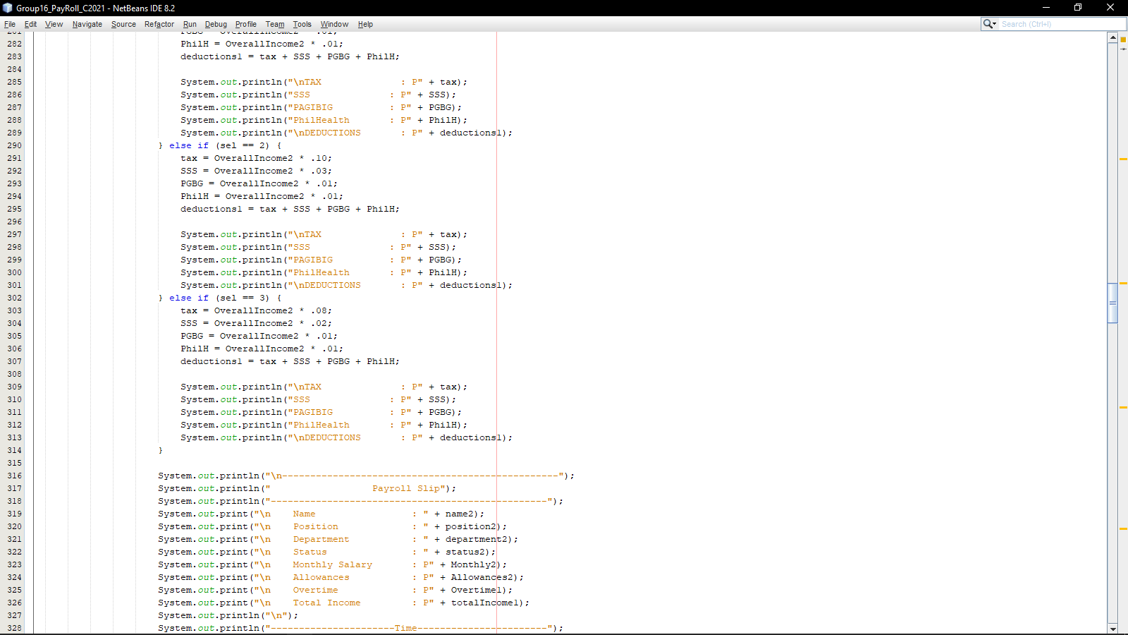 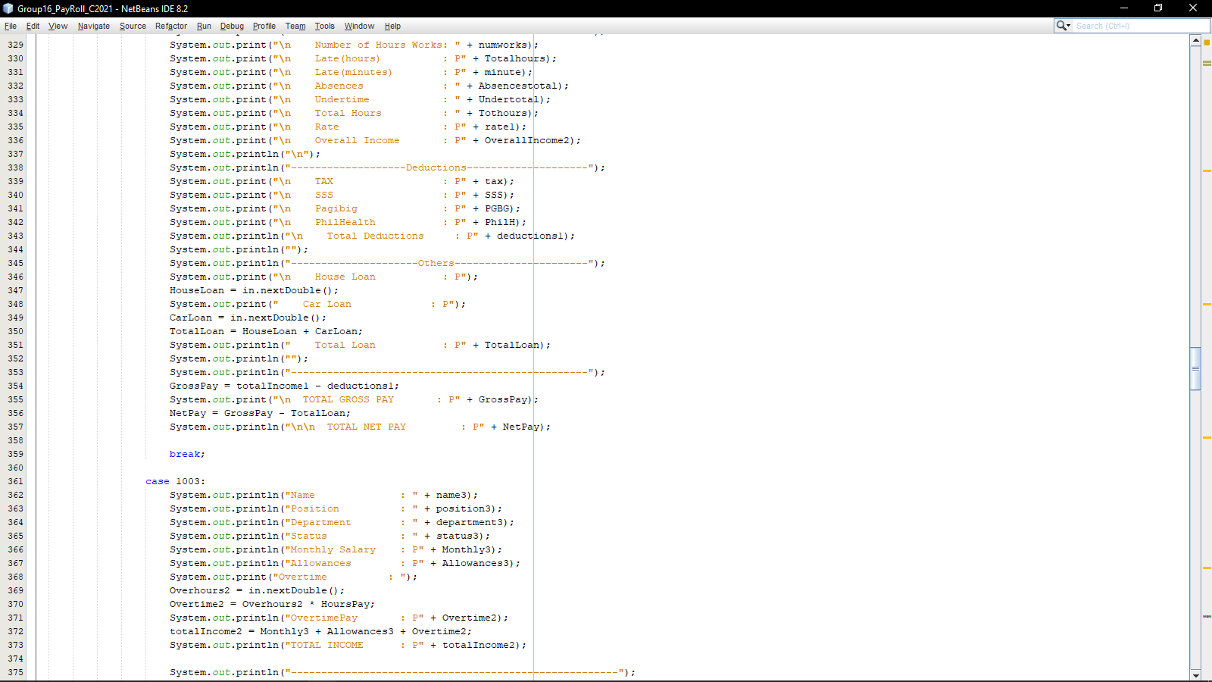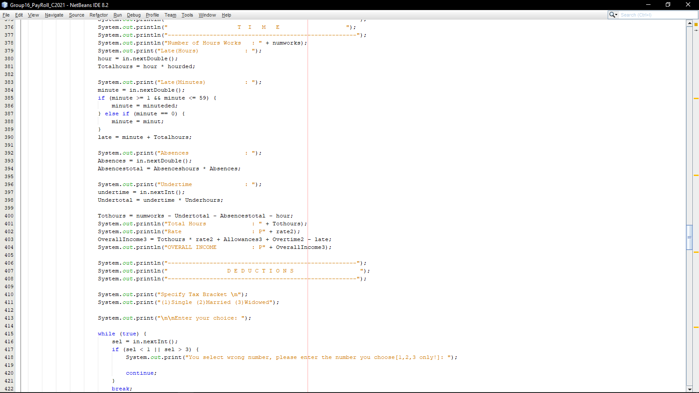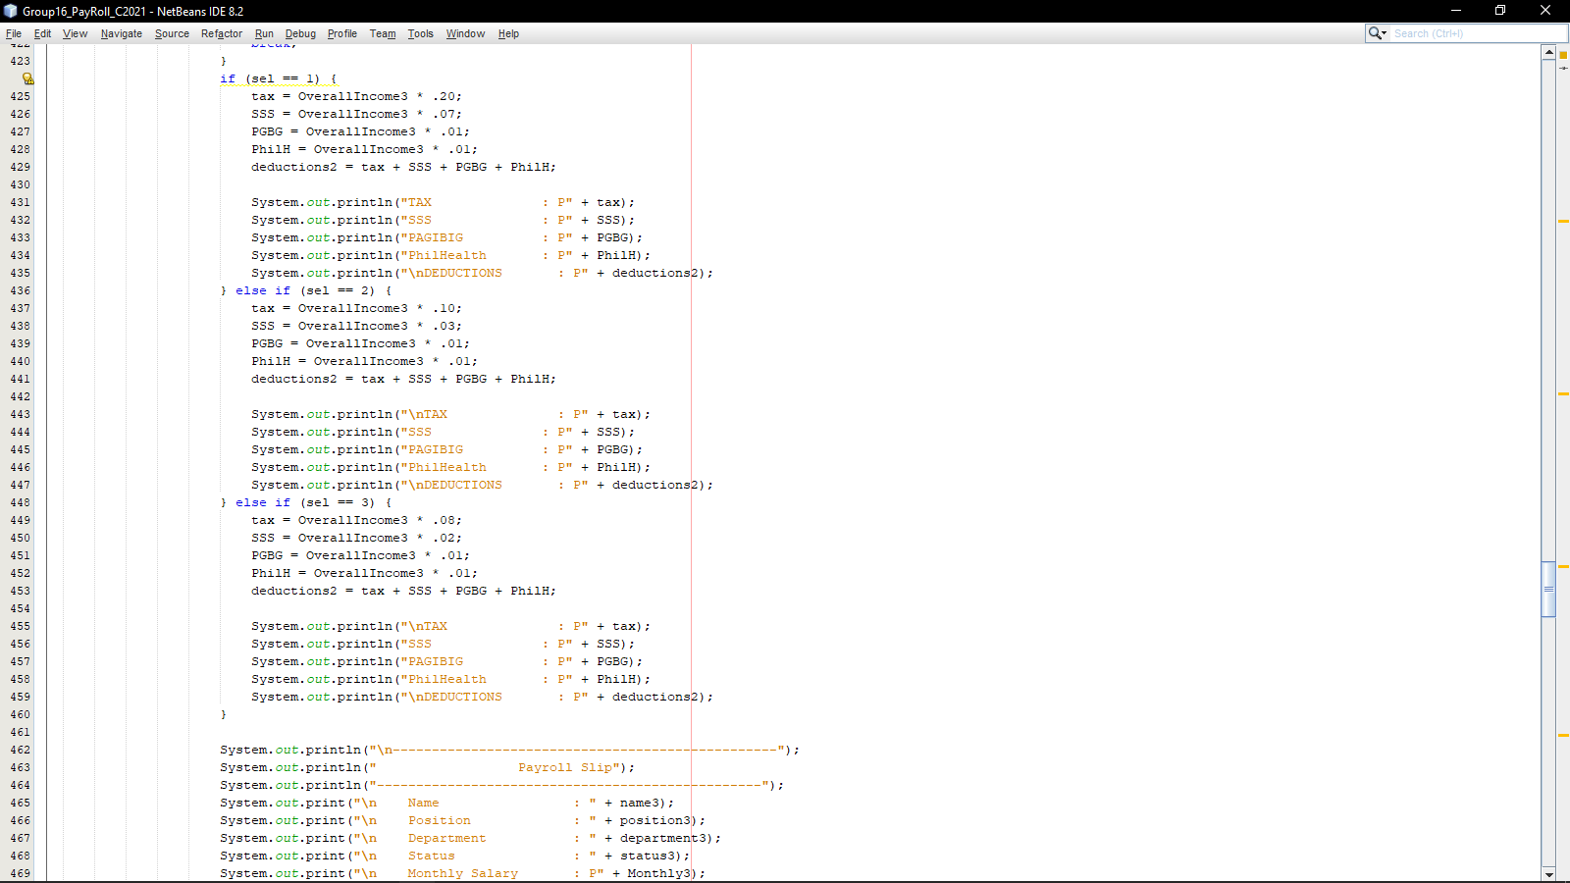 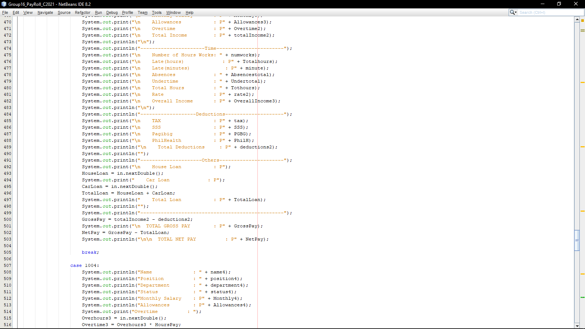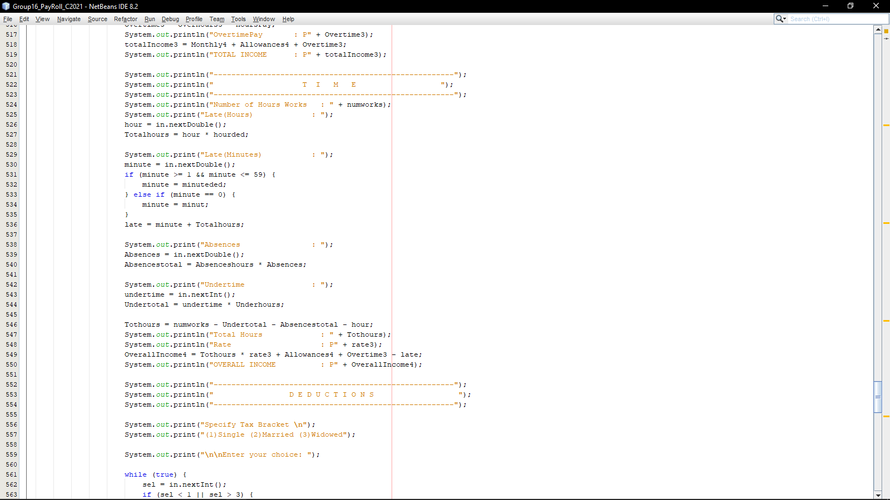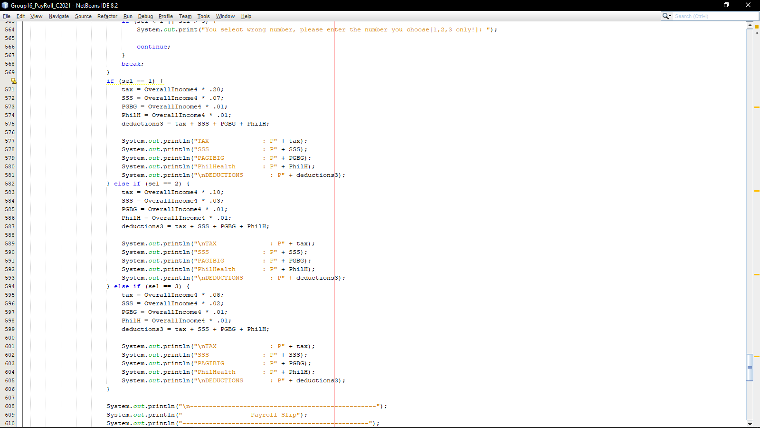 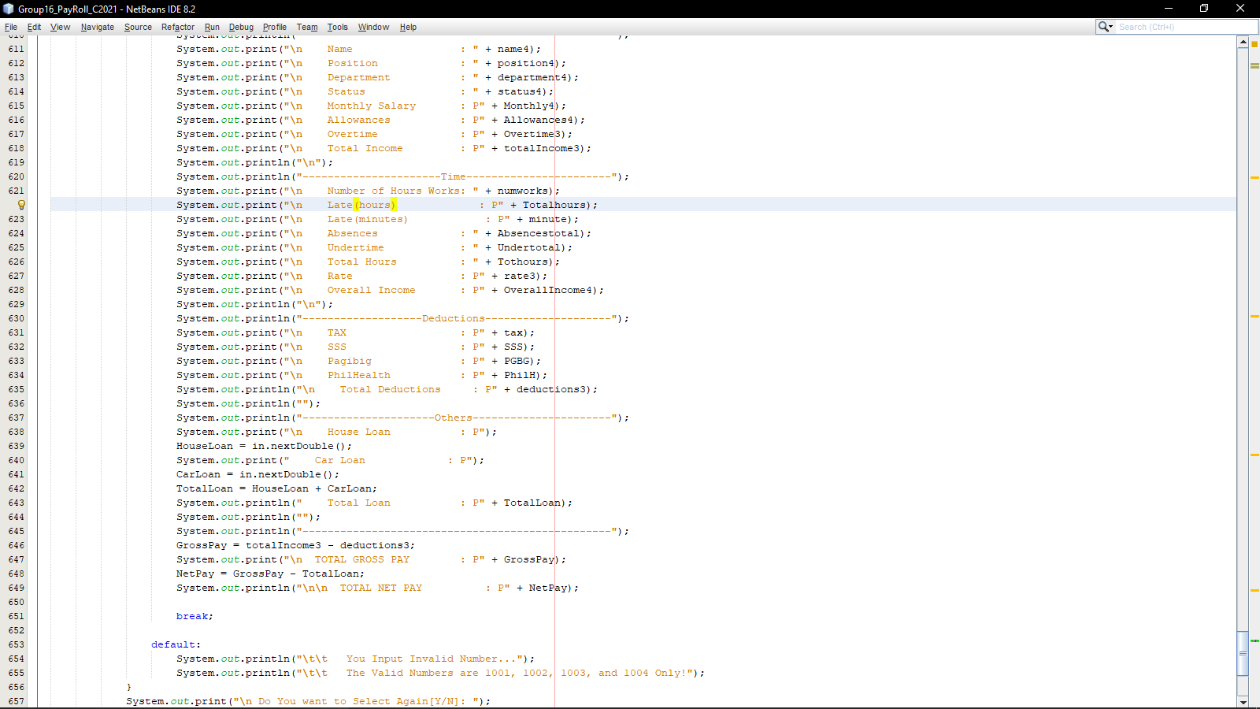

**PAYROLL**

**OUTPUT**

run:

-------------------------------------------------------------------------------------------------------------

TAGUIG CITY Payroll System 101

-------------------------------------------------------------------------------------------------------------

-------------------------------------------------------------------------------------------------------------

|Employee| Employee Name | Position | Department | rate | Monthly | Allowances| Official |

|Number | | | | /hour | Salary | | time= 8hours |

| | | | | | | |Overtime |

| | | | | | | |exceeding |

| | | | | | | |1 hour=P350 |

-------------------------------------------------------------------------------------------------------------

| 1001 | Jose Rizal A | Manager | IT | 520 | 99,840 | 4,500 | |

| 1002 | Andres Bonifacio C | Asst. Manager | IT | 450 | 86,400 | 2,500 | |

| 1003 | Lexi Lore S | Secretary | IT | 350 | 67,200 | 1,500 | |

| 1004 | Ivana Alawi S | Asst. Secretary | IT | 300 | 57,600 | 1,000 | |

-------------------------------------------------------------------------------------------------------------

Enter Employee's Data

Employee Number : 1001

Name : Jose Rizal A

Position : Manager

Department : IT

Status : Single

Monthly Salary : P99840.0

Allowances : P4500.0

Overtime : 6

OvertimePay : P2100.0

TOTAL INCOME : P106440.0

------------------------------------------------------

T I M E

------------------------------------------------------

Number of Hours Works : 192.0

Late(Hours) : 3

Late(Minutes) : 30

Absences : 2

Undertime : 2

Total Hours : 165.0

Rate : P520.0

OVERALL INCOME : P91900.0

------------------------------------------------------

D E D U C T I O N S

------------------------------------------------------

Specify Tax Bracket

(1)Single (2)Married (3)Widowed

Enter your choice: 0

You select wrong number, please enter the number you choose[1,2,3 only!]: 1

TAX : P18380.0

SSS : P6433.000000000001

PAGIBIG : P919.0

PhilHealth : P919.0

DEDUCTIONS : P26651.0

-------------------------------------------------

Payroll Slip

-------------------------------------------------

Name : Jose Rizal A

Position : Manager

Department : IT

Status : Single

Monthly Salary : P99840.0

Allowances : P4500.0

Overtime : P2100.0

Total Income : P106440.0

----------------------Time-----------------------

Number of Hours Works: 192.0

Late(hours) : P450.0

Late(minutes) : P50.0

Absences : 16.0

Undertime : 8

Total Hours : 165.0

Rate : P520.0

Overall Income : P91900.0

-------------------Deductions--------------------

TAX : P18380.0

SSS : P6433.000000000001

Pagibig : P919.0

PhilHealth : P919.0

Total Deductions : P26651.0

---------------------Others----------------------

House Loan : P5000

Car Loan : P2000

Total Loan : P7000.0

-------------------------------------------------

TOTAL GROSS PAY : P65249.0

TOTAL NET PAY : P58249.0

Do You want to Select Again[Y/N]: Y

-------------------------------------------------------------------------------------------------------------

TAGUIG CITY Payroll System 101

-------------------------------------------------------------------------------------------------------------

-------------------------------------------------------------------------------------------------------------

|Employee| Employee Name | Position | Department | rate | Monthly | Allowances| Official |

|Number | | | | /hour | Salary | | time= 8hours |

| | | | | | | |Overtime |

| | | | | | | |exceeding |

| | | | | | | |1 hour=P350 |

-------------------------------------------------------------------------------------------------------------

| 1001 | Jose Rizal A | Manager | IT | 520 | 99,840 | 4,500 | |

| 1002 | Andres Bonifacio C | Asst. Manager | IT | 450 | 86,400 | 2,500 | |

| 1003 | Lexi Lore S | Secretary | IT | 350 | 67,200 | 1,500 | |

| 1004 | Ivana Alawi S | Asst. Secretary | IT | 300 | 57,600 | 1,000 | |

-------------------------------------------------------------------------------------------------------------

Enter Employee's Data

Employee Number : 1002

Name : Andres Bonifacio C

Position : Assistant Manager

Department : IT

Status : Single

Monthly Salary : P86400.0

Allowances : P2500.0

Overtime : 4

OvertimePay : P1400.0

TOTAL INCOME : P90300.0

------------------------------------------------------

T I M E

------------------------------------------------------

Number of Hours Works : 192.0

Late(Hours) : 10

Late(Minutes) : 0

Absences : 5

Undertime : 1

Total Hours : 138.0

Rate : P450.0

OVERALL INCOME : P64500.0

------------------------------------------------------

D E D U C T I O N S

------------------------------------------------------

Specify Tax Bracket

(1)Single (2)Married (3)Widowed

Enter your choice: 4

You select wrong number, please enter the number you choose[1,2,3 only!]: 1

TAX : P9675.0

SSS : P3225.0

PAGIBIG : P645.0

PhilHealth : P645.0

DEDUCTIONS : P14190.0

-------------------------------------------------

Payroll Slip

-------------------------------------------------

Name : Andres Bonifacio C

Position : Assistant Manager

Department : IT

Status : Single

Monthly Salary : P86400.0

Allowances : P2500.0

Overtime : P1400.0

Total Income : P90300.0

----------------------Time-----------------------

Number of Hours Works: 192.0

Late(hours) : P1500.0

Late(minutes) : P0.0

Absences : 40.0

Undertime : 4

Total Hours : 138.0

Rate : P450.0

Overall Income : P64500.0

-------------------Deductions--------------------

TAX : P9675.0

SSS : P3225.0

Pagibig : P645.0

PhilHealth : P645.0

Total Deductions : P14190.0

---------------------Others----------------------

House Loan : P3000

Car Loan : P10000

Total Loan : P13000.0

-------------------------------------------------

TOTAL GROSS PAY : P76110.0

TOTAL NET PAY : P63110.0

Do You want to Select Again[Y/N]: Y

-------------------------------------------------------------------------------------------------------------

TAGUIG CITY Payroll System 101

-------------------------------------------------------------------------------------------------------------

-------------------------------------------------------------------------------------------------------------

|Employee| Employee Name | Position | Department | rate | Monthly | Allowances| Official |

|Number | | | | /hour | Salary | | time= 8hours |

| | | | | | | |Overtime |

| | | | | | | |exceeding |

| | | | | | | |1 hour=P350 |

-------------------------------------------------------------------------------------------------------------

| 1001 | Jose Rizal A | Manager | IT | 520 | 99,840 | 4,500 | |

| 1002 | Andres Bonifacio C | Asst. Manager | IT | 450 | 86,400 | 2,500 | |

| 1003 | Lexi Lore S | Secretary | IT | 350 | 67,200 | 1,500 | |

| 1004 | Ivana Alawi S | Asst. Secretary | IT | 300 | 57,600 | 1,000 | |

-------------------------------------------------------------------------------------------------------------

Enter Employee's Data

Employee Number : 1003

Name : Lexi Lore S

Position : Secretary

Department : IT

Status : Married

Monthly Salary : P67200.0

Allowances : P1500.0

Overtime : 10

OvertimePay : P3500.0

TOTAL INCOME : P72200.0

------------------------------------------------------

T I M E

------------------------------------------------------

Number of Hours Works : 192.0

Late(Hours) : 8

Late(Minutes) : 15

Absences : 1

Undertime : 1

Total Hours : 172.0

Rate : P350.0

OVERALL INCOME : P63950.0

------------------------------------------------------

D E D U C T I O N S

------------------------------------------------------

Specify Tax Bracket

(1)Single (2)Married (3)Widowed

Enter your choice: 2

TAX : P6395.0

SSS : P1918.5

PAGIBIG : P639.5

PhilHealth : P639.5

DEDUCTIONS : P9592.5

-------------------------------------------------

Payroll Slip

-------------------------------------------------

Name : Lexi Lore S

Position : Secretary

Department : IT

Status : Married

Monthly Salary : P67200.0

Allowances : P1500.0

Overtime : P3500.0

Total Income : P72200.0

----------------------Time-----------------------

Number of Hours Works: 192.0

Late(hours) : P1200.0

Late(minutes) : P50.0

Absences : 8.0

Undertime : 4

Total Hours : 172.0

Rate : P350.0

Overall Income : P63950.0

-------------------Deductions--------------------

TAX : P6395.0

SSS : P1918.5

Pagibig : P639.5

PhilHealth : P639.5

Total Deductions : P9592.5

---------------------Others----------------------

House Loan : P1000

Car Loan : P1000

Total Loan : P2000.0

-------------------------------------------------

TOTAL GROSS PAY : P62607.5

TOTAL NET PAY : P60607.5

Do You want to Select Again[Y/N]: Y

-------------------------------------------------------------------------------------------------------------

TAGUIG CITY Payroll System 101

-------------------------------------------------------------------------------------------------------------

-------------------------------------------------------------------------------------------------------------

|Employee| Employee Name | Position | Department | rate | Monthly | Allowances| Official |

|Number | | | | /hour | Salary | | time= 8hours |

| | | | | | | |Overtime |

| | | | | | | |exceeding |

| | | | | | | |1 hour=P350 |

-------------------------------------------------------------------------------------------------------------

| 1001 | Jose Rizal A | Manager | IT | 520 | 99,840 | 4,500 | |

| 1002 | Andres Bonifacio C | Asst. Manager | IT | 450 | 86,400 | 2,500 | |

| 1003 | Lexi Lore S | Secretary | IT | 350 | 67,200 | 1,500 | |

| 1004 | Ivana Alawi S | Asst. Secretary | IT | 300 | 57,600 | 1,000 | |

-------------------------------------------------------------------------------------------------------------

Enter Employee's Data

Employee Number : 1004

Name : Ivana Alawi S

Position : Assistant Secretary

Department : IT

Status : Widowed

Monthly Salary : P57600.0

Allowances : P1000.0

Overtime : 1

OvertimePay : P350.0

TOTAL INCOME : P58950.0

------------------------------------------------------

T I M E

------------------------------------------------------

Number of Hours Works : 192.0

Late(Hours) : 7

Late(Minutes) : 50

Absences : 5

Undertime : 5

Total Hours : 125.0

Rate : P300.0

OVERALL INCOME : P37750.0

------------------------------------------------------

D E D U C T I O N S

------------------------------------------------------

Specify Tax Bracket

(1)Single (2)Married (3)Widowed

Enter your choice: 3

TAX : P3020.0

SSS : P755.0

PAGIBIG : P377.5

PhilHealth : P377.5

DEDUCTIONS : P4530.0

-------------------------------------------------

Payroll Slip

-------------------------------------------------

Name : Ivana Alawi S

Position : Assistant Secretary

Department : IT

Status : Widowed

Monthly Salary : P57600.0

Allowances : P1000.0

Overtime : P350.0

Total Income : P58950.0

----------------------Time-----------------------

Number of Hours Works: 192.0

Late(hours) : P1050.0

Late(minutes) : P50.0

Absences : 40.0

Undertime : 20

Total Hours : 125.0

Rate : P300.0

Overall Income : P37750.0

-------------------Deductions--------------------

TAX : P3020.0

SSS : P755.0

Pagibig : P377.5

PhilHealth : P377.5

Total Deductions : P4530.0

---------------------Others----------------------

House Loan : P6000

Car Loan : P6000

Total Loan : P12000.0

-------------------------------------------------

TOTAL GROSS PAY : P54420.0

TOTAL NET PAY : P42420.0

Do You want to Select Again[Y/N]: Y

-------------------------------------------------------------------------------------------------------------

TAGUIG CITY Payroll System 101

-------------------------------------------------------------------------------------------------------------

-------------------------------------------------------------------------------------------------------------

|Employee| Employee Name | Position | Department | rate | Monthly | Allowances| Official |

|Number | | | | /hour | Salary | | time= 8hours |

| | | | | | | |Overtime |

| | | | | | | |exceeding |

| | | | | | | |1 hour=P350 |

-------------------------------------------------------------------------------------------------------------

| 1001 | Jose Rizal A | Manager | IT | 520 | 99,840 | 4,500 | |

| 1002 | Andres Bonifacio C | Asst. Manager | IT | 450 | 86,400 | 2,500 | |

| 1003 | Lexi Lore S | Secretary | IT | 350 | 67,200 | 1,500 | |

| 1004 | Ivana Alawi S | Asst. Secretary | IT | 300 | 57,600 | 1,000 | |

-------------------------------------------------------------------------------------------------------------

Enter Employee's Data

Employee Number : 1005

You Input Invalid Number...

The Valid Numbers are 1001, 1002, 1003, and 1004 Only!

Do You want to Select Again[Y/N]: N

BUILD SUCCESSFUL (total time: 6 minutes 45 seconds)